Deploy Applications to Cloud Platforms

Problem Statement:

Now that we have our cloud development environment ready, we will deploy a simple application to AWS. The goal is to build a Node.js app, containerize it with Docker, push the image to Amazon Elastic Container Registry (ECR), and run it on Amazon Elastic Container Service (ECS) using Fargate. This will demonstrate the full flow of deploying an app to the cloud.

Tools/Software Versions:

1. Operating System: Amazon Linux 2023 (on EC2)

2. AWS CLI: v2.28.21 (run on local machine or EC2)

3. Docker: v25.0.8 (installed on EC2)

4. Git: v2.50.1 (installed on EC2)

5. Node.js: v20.19.4 LTS (installed on EC2)

6. AWS Services: Amazon ECR, Amazon ECS with Fargate

Hands-on Steps:

Step 1: Create a Minimal Node.js Application (Inside EC2)

1. Move into your workspace:

cd ~/workspace

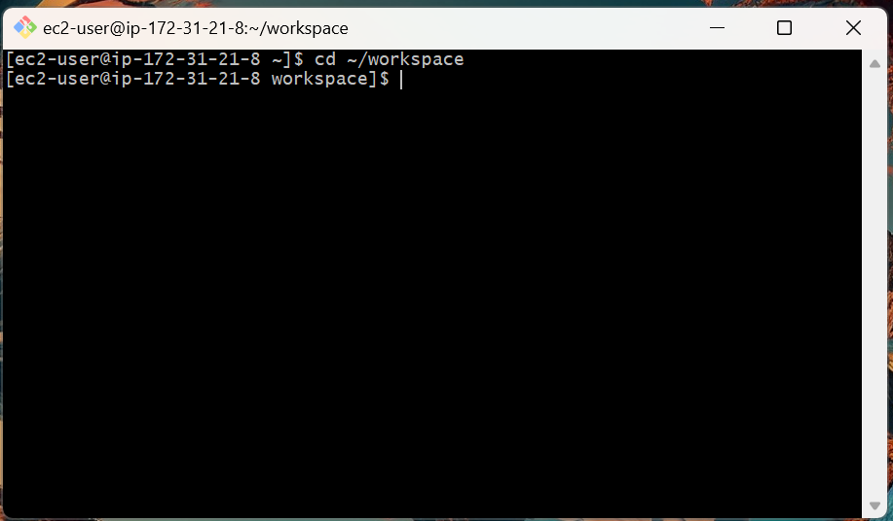

2. Create a new project folder:

mkdir sample-app

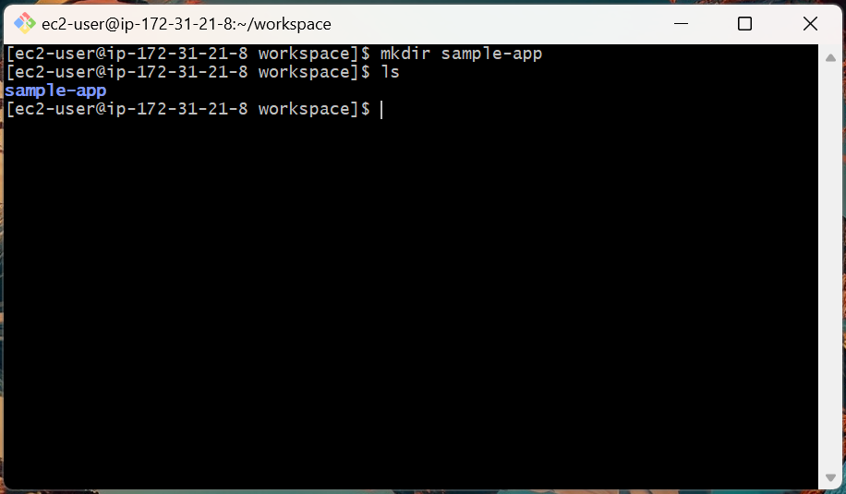

3. Enter the folder:

cd sample-app

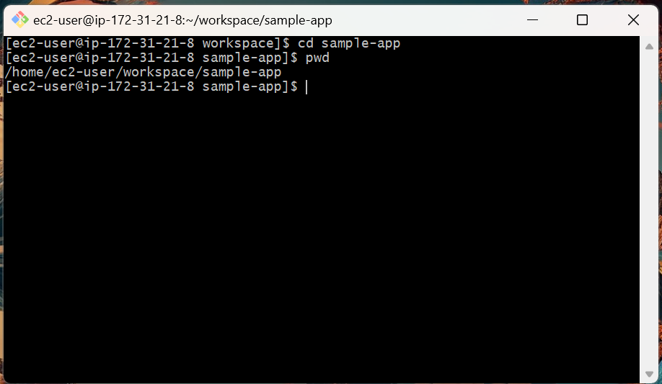

4. Create the application file:

nano server.js

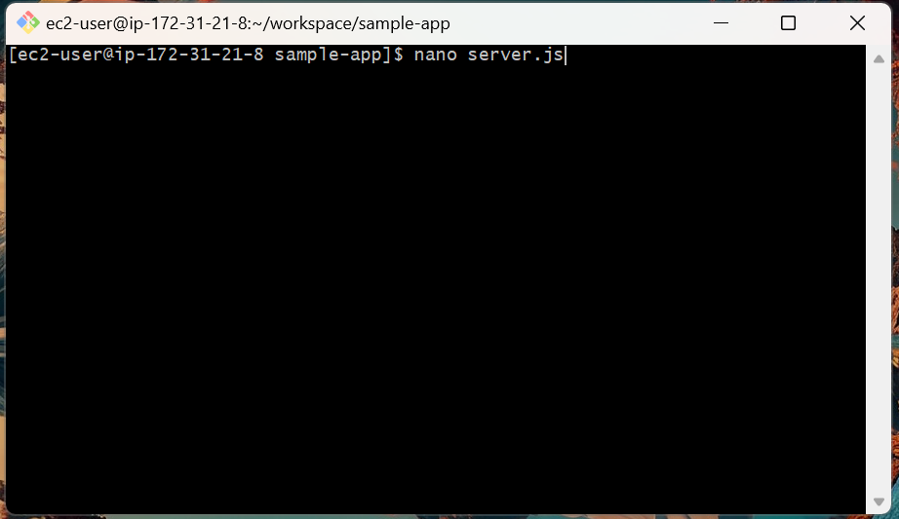

5. Paste the following code into server.js:

const http = require('http');
const port = 3000;

const server = http.createServer((req, res) => {
if (req.url === '/health') {
res.writeHead(200, {'Content-Type': 'application/json'});
res.end(JSON.stringify({status: 'healthy'}));
} else {
res.writeHead(200);
res.end('Hello from ECS Fargate!');
}
});

server.listen(port, () => console.log(`Listening on ${port}`));

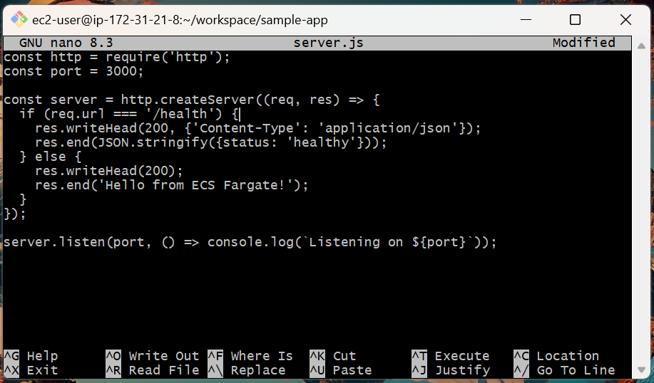

6. Save and exit (CTRL+O, Enter, then CTRL+X).

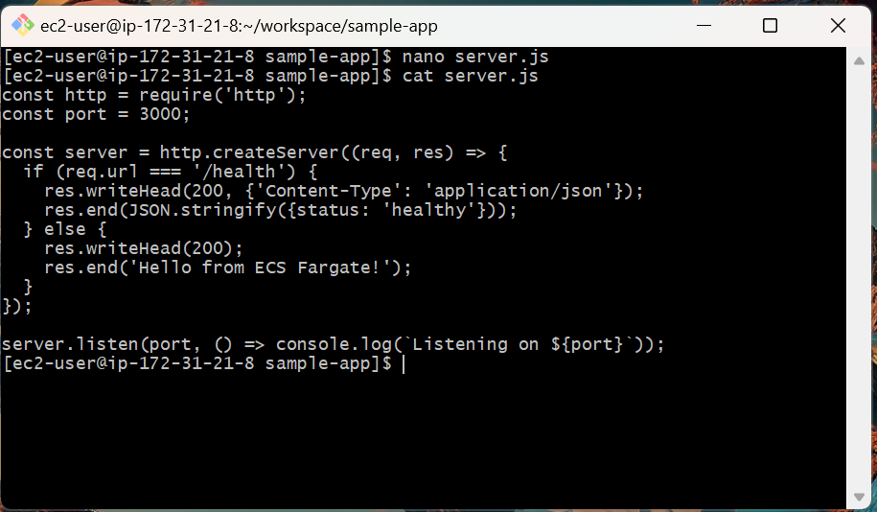

Step 2: Create a Dockerfile

1. Create the Dockerfile:

nano Dockerfile

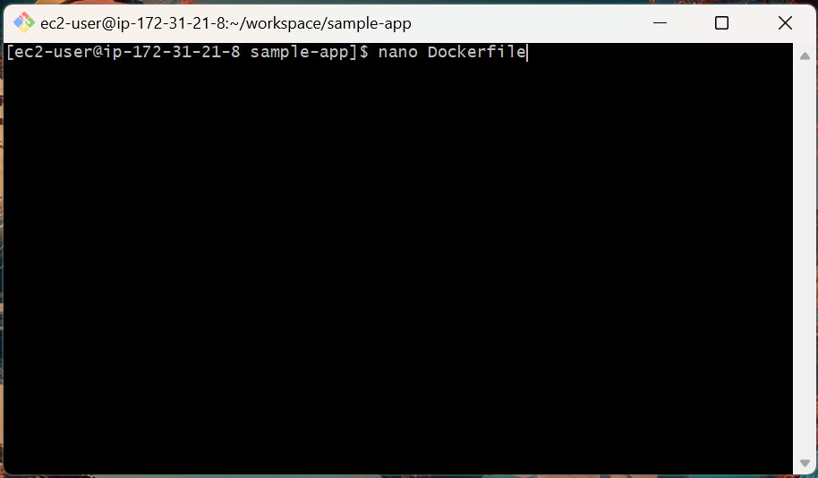

2. Paste the following into the file:

FROM node:20-alpine
WORKDIR /app
COPY server.js .
EXPOSE 3000
CMD ["node", "server.js"]

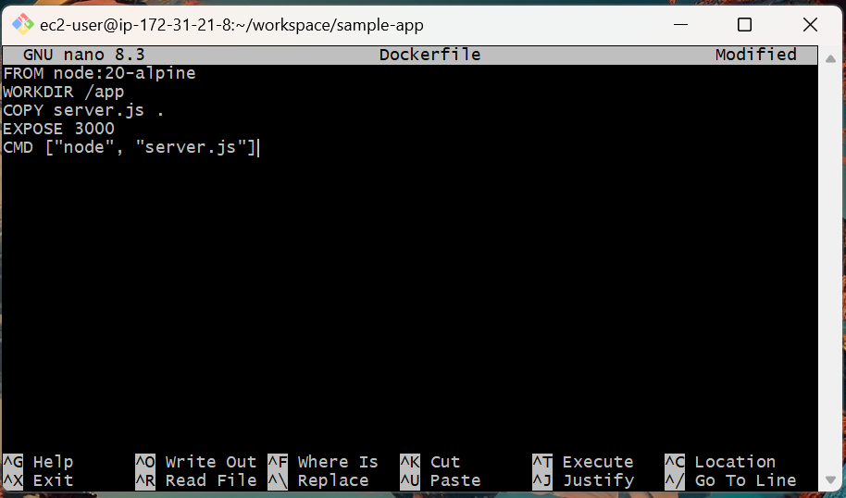

3. Save and exit (CTRL+O, Enter, then CTRL+X).

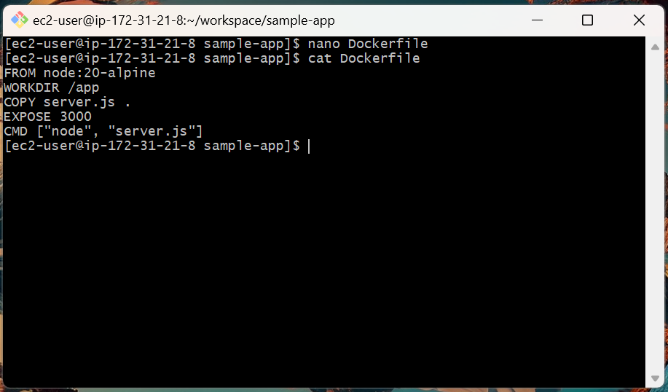

Step 3: Build and Test Docker Image

1. Build the Docker image:

docker build -t sample-app:latest .

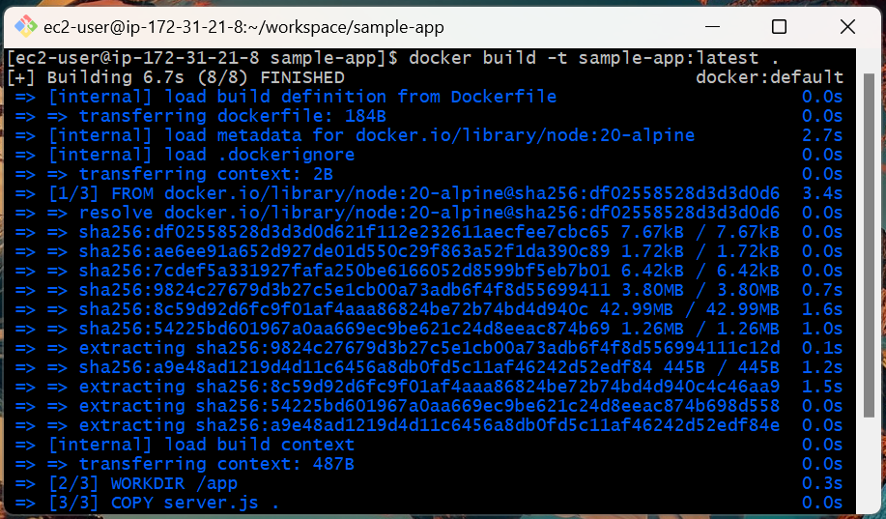

2. Run the container locally:

docker run -d -p 3000:3000 sample-app:latest

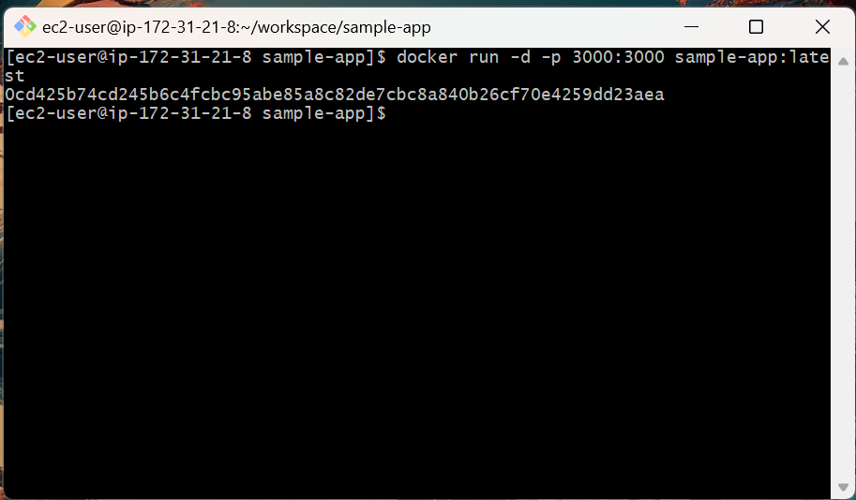

3. Test the application:

curl http://localhost:3000/health

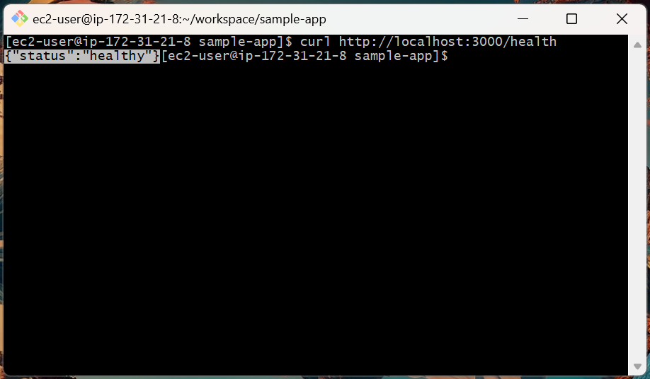

4. Stop and remove the container:

docker ps

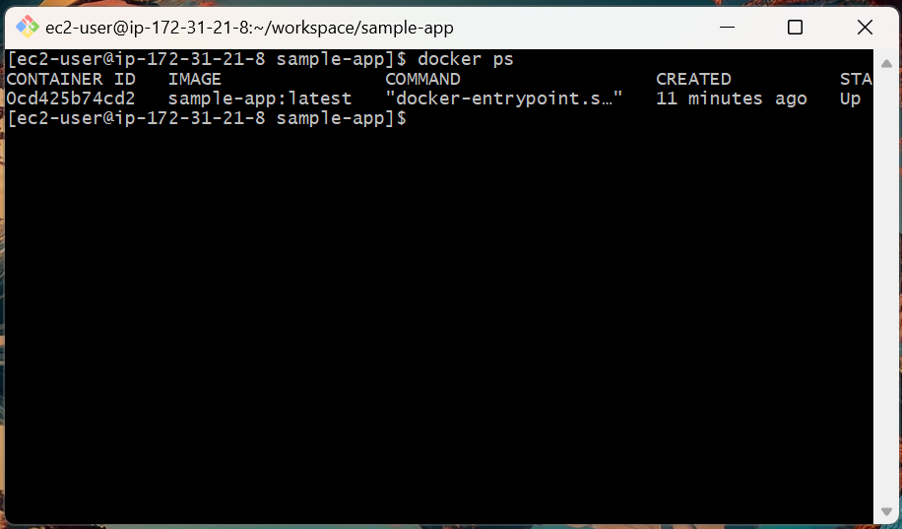

docker stop 0cd425b74cd2
docker rm 0cd425b74cd2

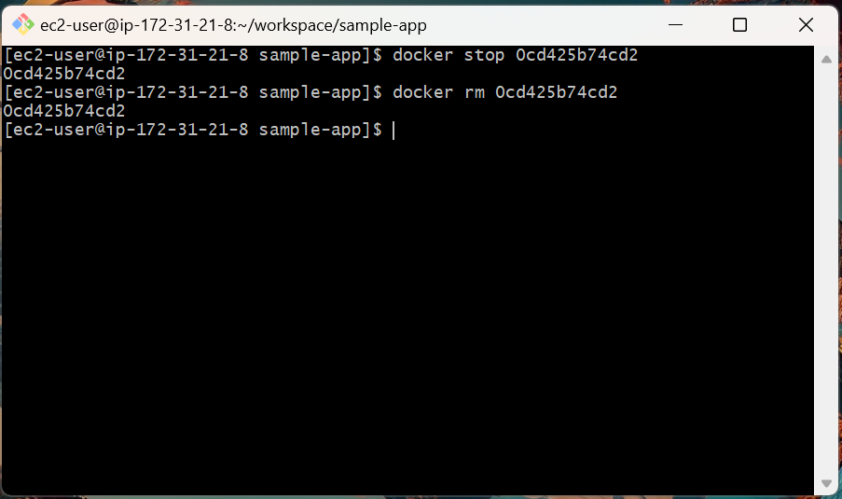

Step 4: Create an IAM User for ECR/ECS Access

Before pushing the Docker image to ECR, we need AWS credentials.

1. Open the AWS Management Console → IAM → Users → Create user.

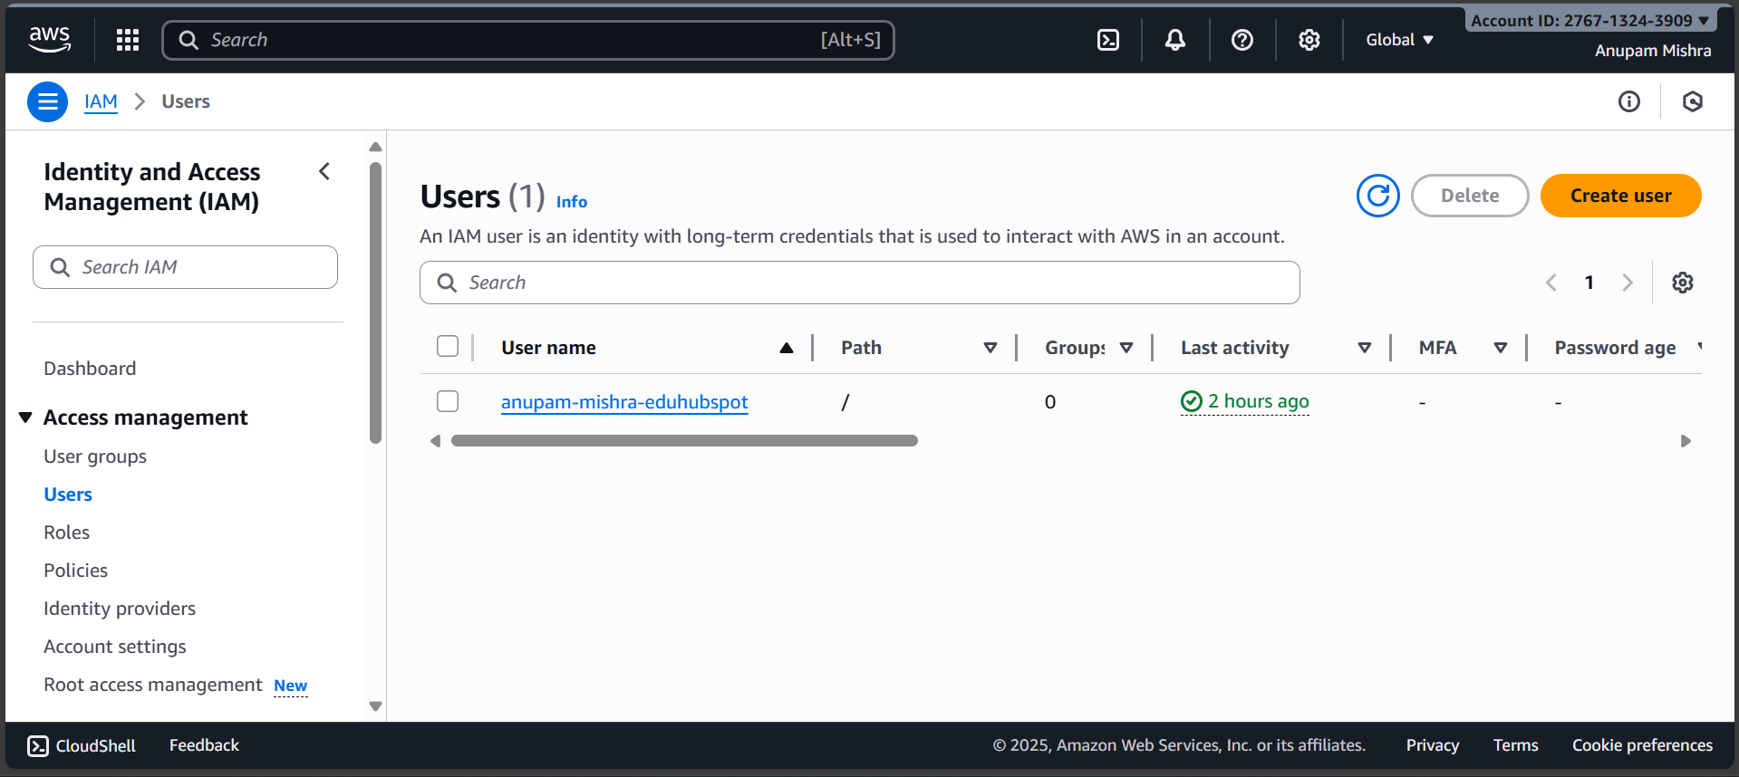

2. Enter a username: ecs-deployer

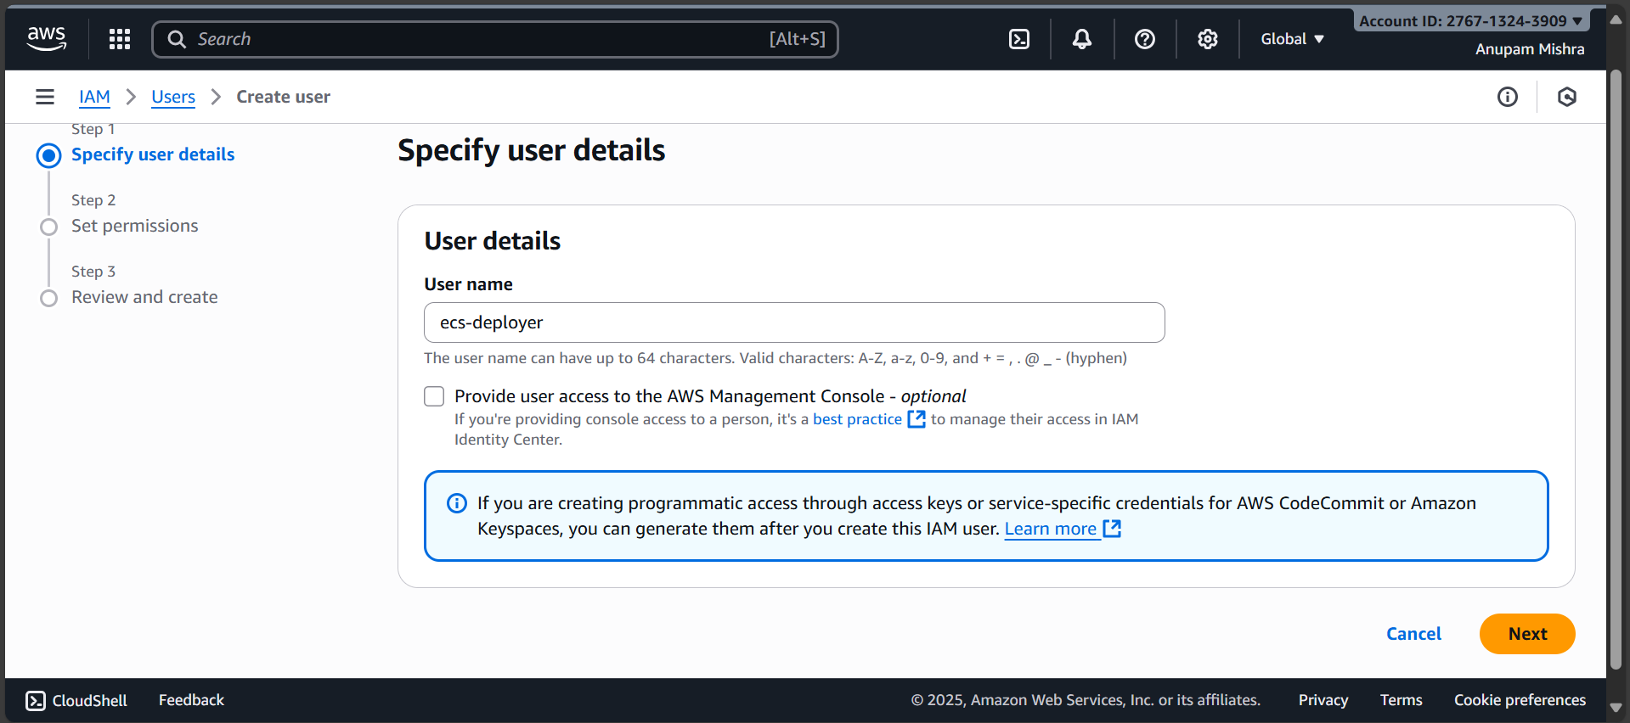

Leave the Provide user access to the AWS Management Console box unchecked, because we only need programmatic access (CLI/ECR/ECS).

3. Set Permissions:

Select Attach policies directly. We’re choosing this so the user gets only the policies we need, without creating extra groups.

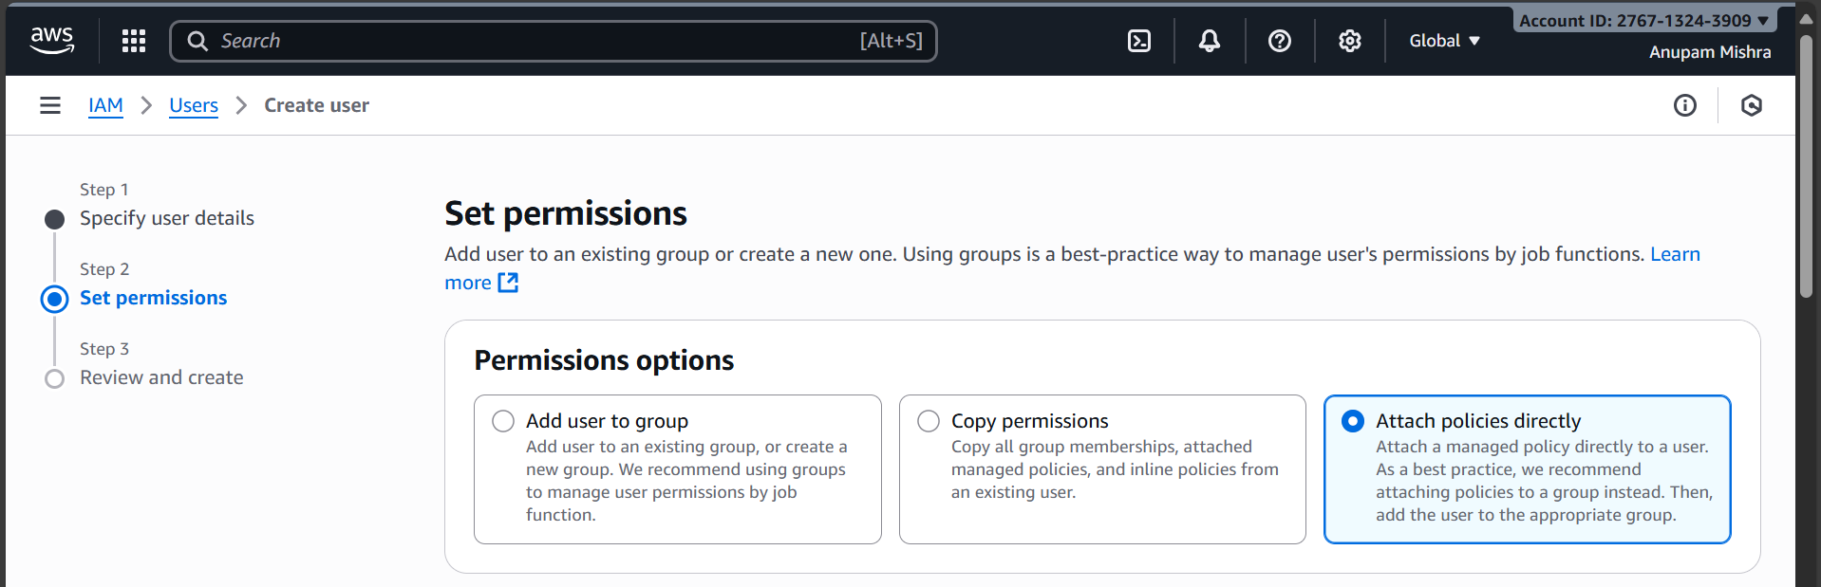

In the list of policies, search and select the following:

- AmazonEC2ContainerRegistryFullAccess
- AmazonECS_FullAccess
- CloudWatchLogsFullAccess

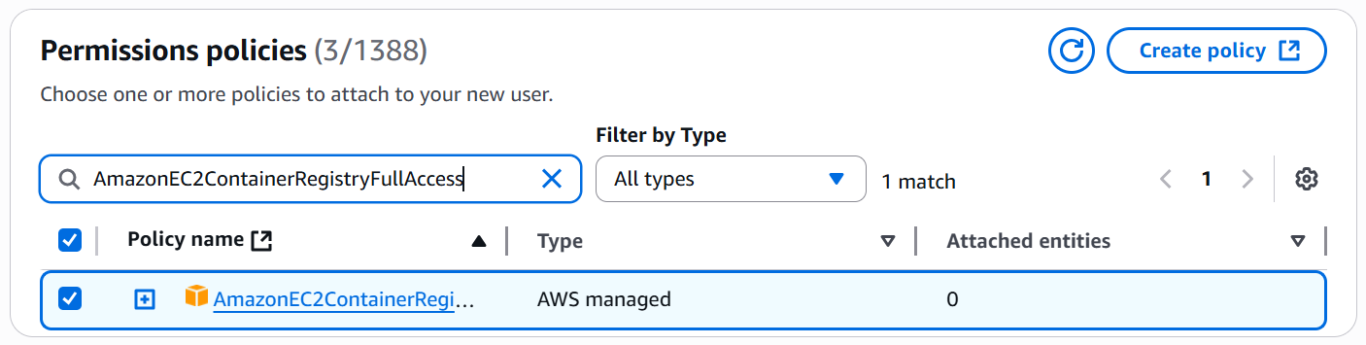

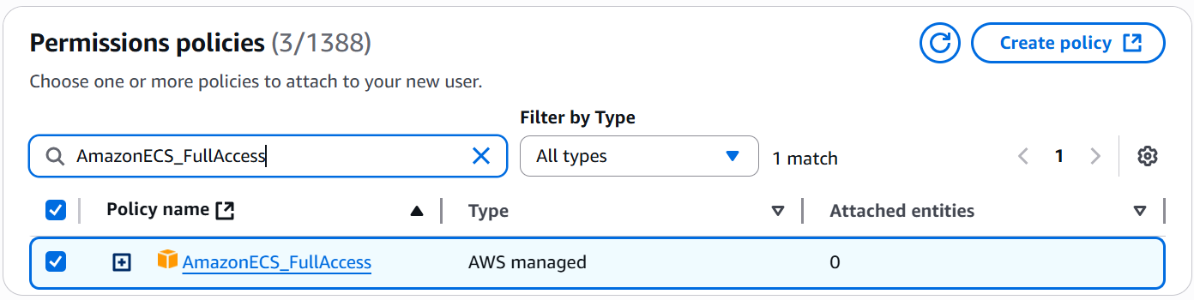

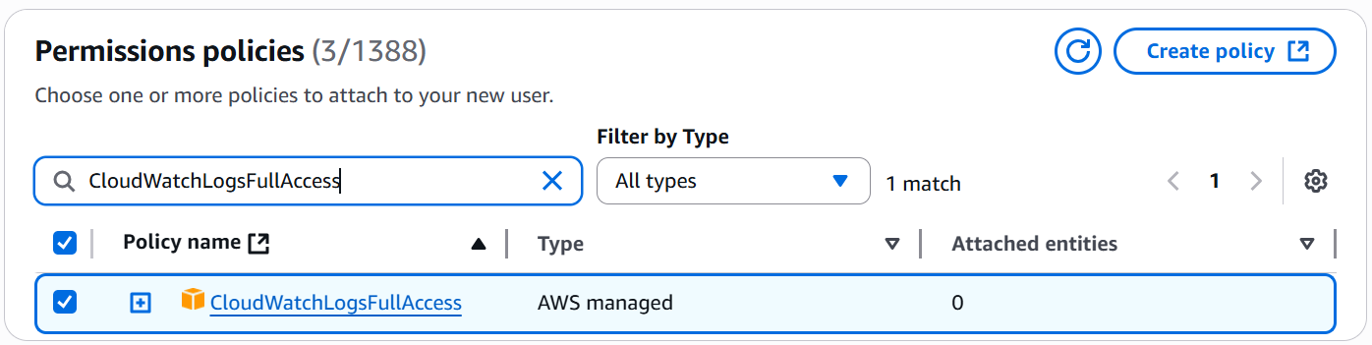

3. Review and Create:

Finish creating the user and download the .csv credentials file with Access Key ID and Secret Access Key.

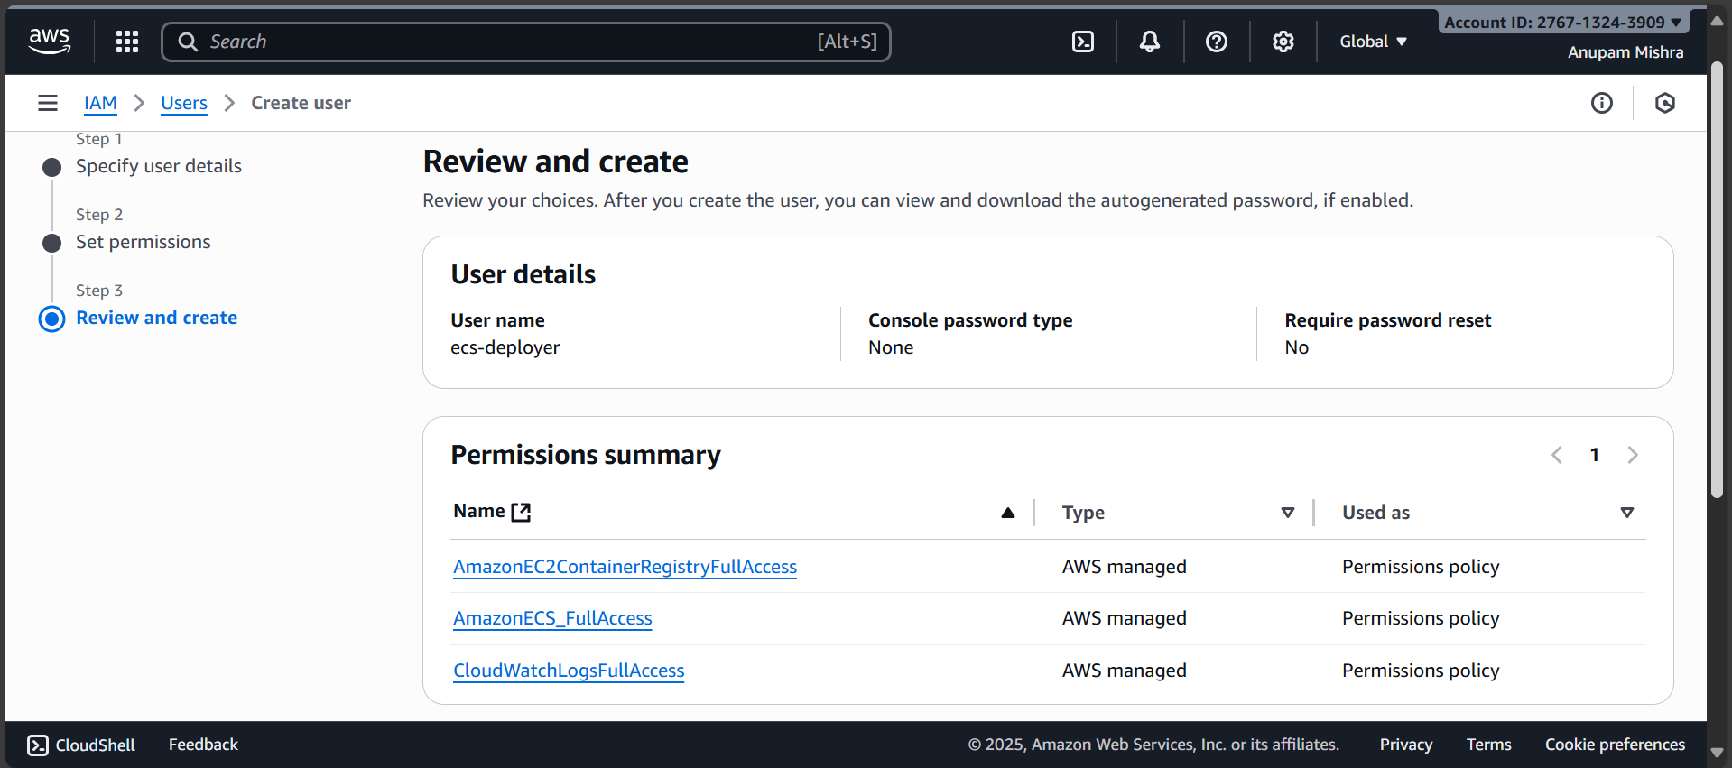

4. Back on your EC2 instance, configure AWS CLI:

aws configure

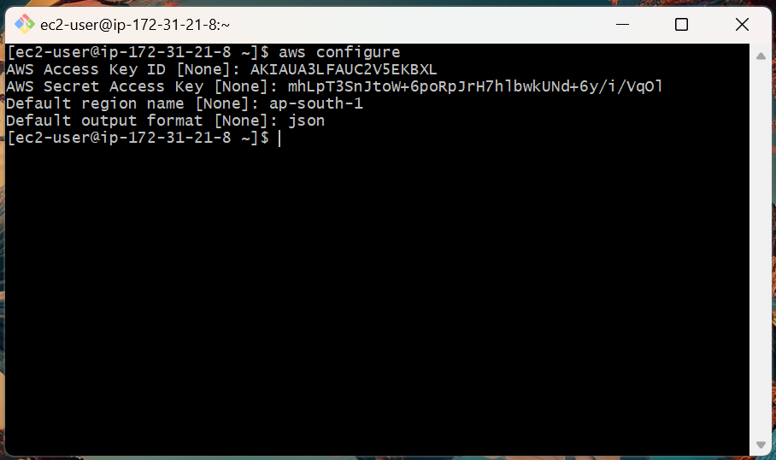

Enter when prompted:

- AWS Access Key ID → from IAM user
- AWS Secret Access Key → from IAM user
- Default region → ap-south-1
- Default output format → json

5. Verify configuration:

aws sts get-caller-identity

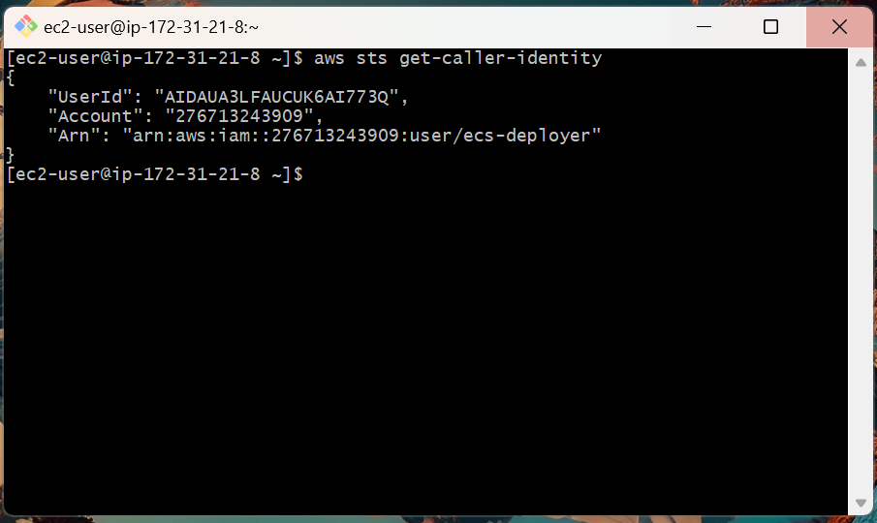

Step 5: Push Image to Amazon ECR

1. Get account ID:

ACCOUNT_ID=$(aws sts get-caller-identity --query Account --output text)
echo $ACCOUNT_ID

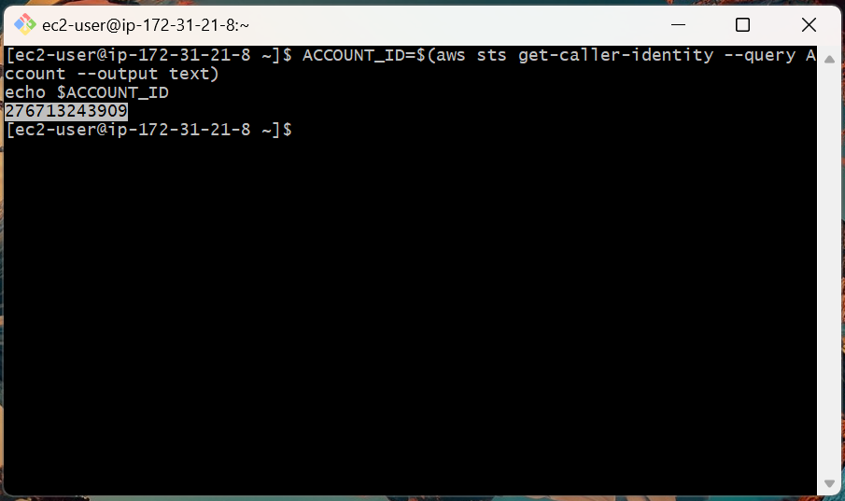

2. Set region:

REGION=ap-south-1
echo $REGION

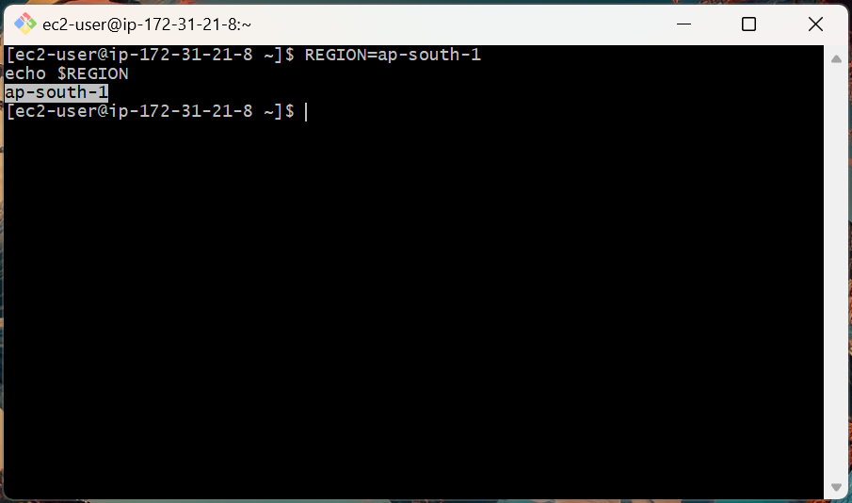

3. Define repository URI for later use:

REPO_URI=276713243909.dkr.ecr.ap-south-1.amazonaws.com/sample-app
echo $REPO_URI

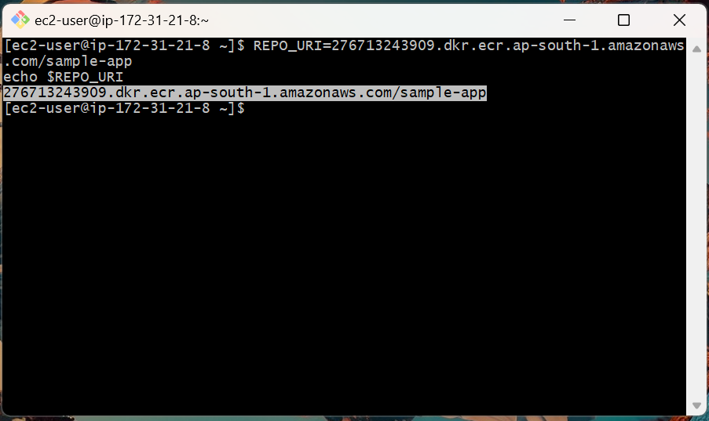

4. Create the ECR repository:

aws ecr create-repository --repository-name sample-app --region ap-south-1 || true

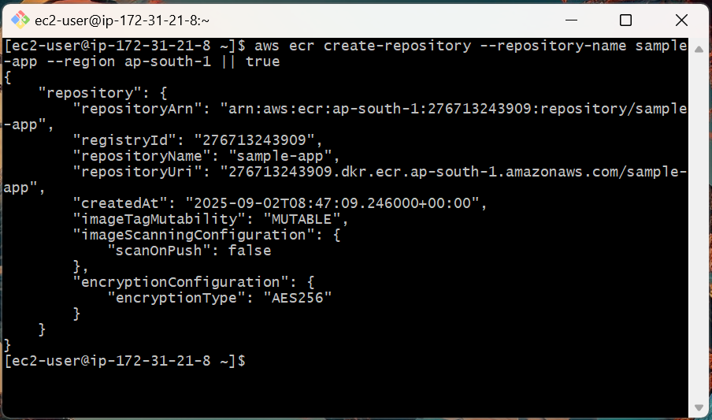

5. Authenticate Docker with ECR:

aws ecr get-login-password --region ap-south-1 \
| docker login --username AWS --password-stdin 276713243909.dkr.ecr.ap-south-1.amazonaws.com

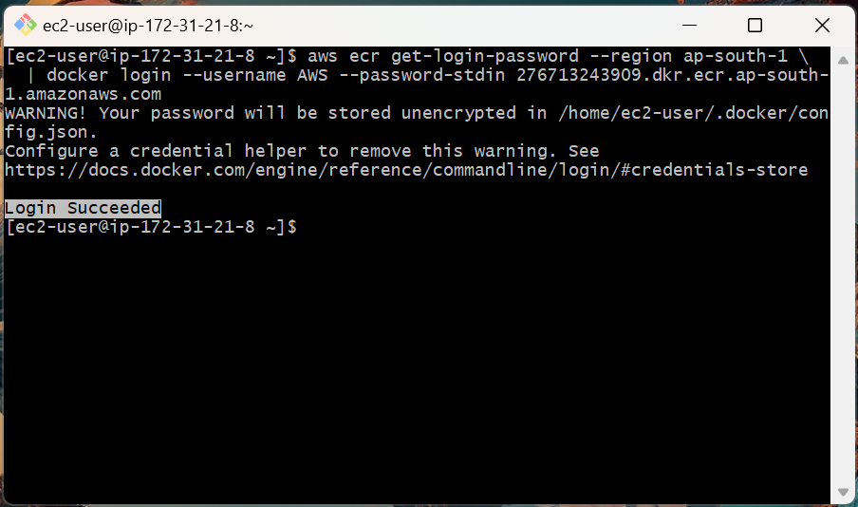

6. Tag your local image with the full ECR URI:

docker tag sample-app:latest 276713243909.dkr.ecr.ap-south-1.amazonaws.com/sample-app:latest

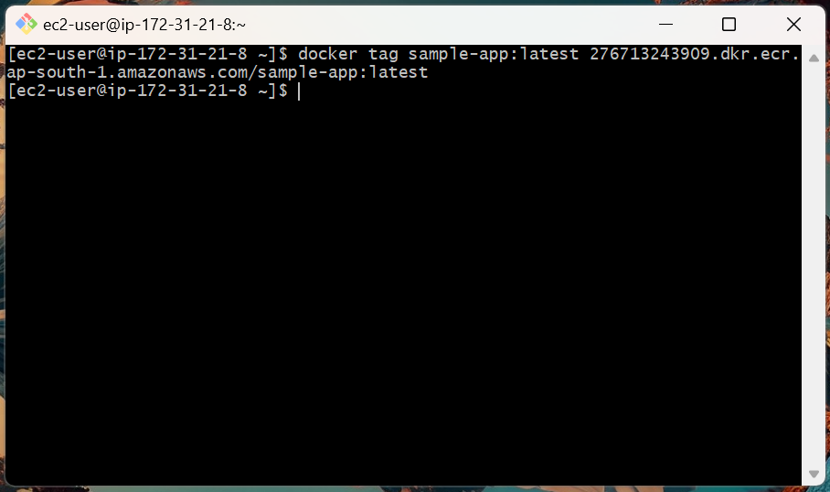

7. Push the image to ECR

docker push 276713243909.dkr.ecr.ap-south-1.amazonaws.com/sample-app:latest

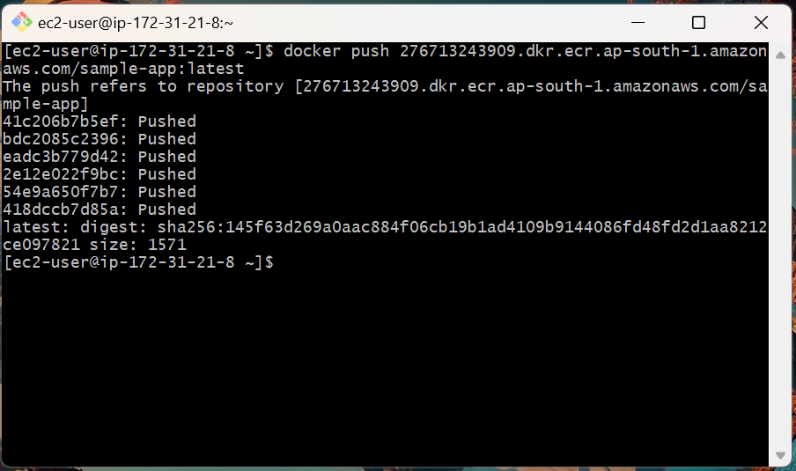

8. Verify that the image was uploaded successfully:

aws ecr list-images --repository-name sample-app --region ap-south-1 \
--query 'imageIds[*].imageTag' --output text

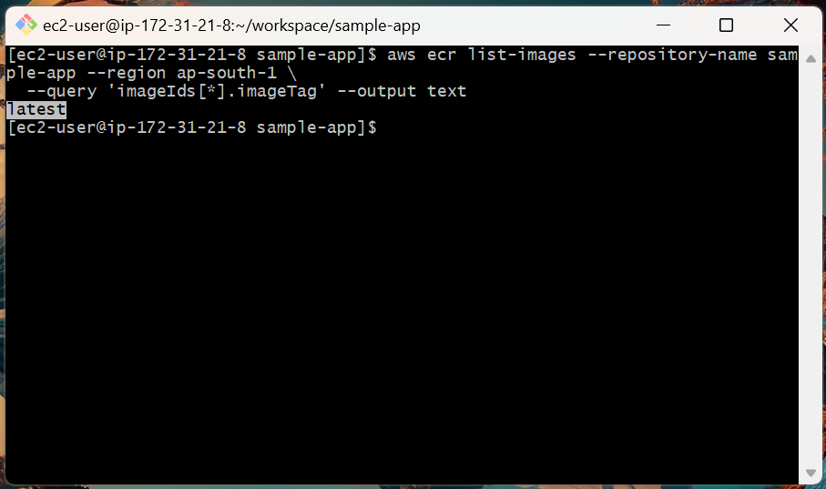

Step 6: Deploy Application on ECS with Fargate

1. In ECS Console, go to Clusters → Create Cluster.

Cluster name: sample-app-cluster

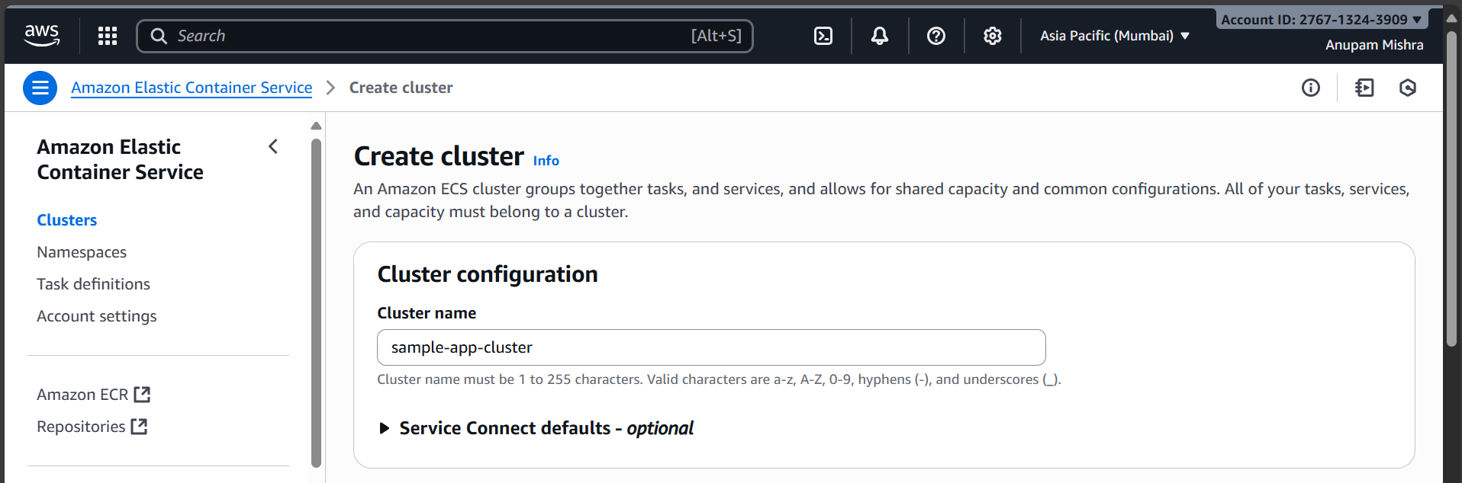

Keep AWS Fargate (serverless) selected. This ensures that your service runs without managing EC2 instances.

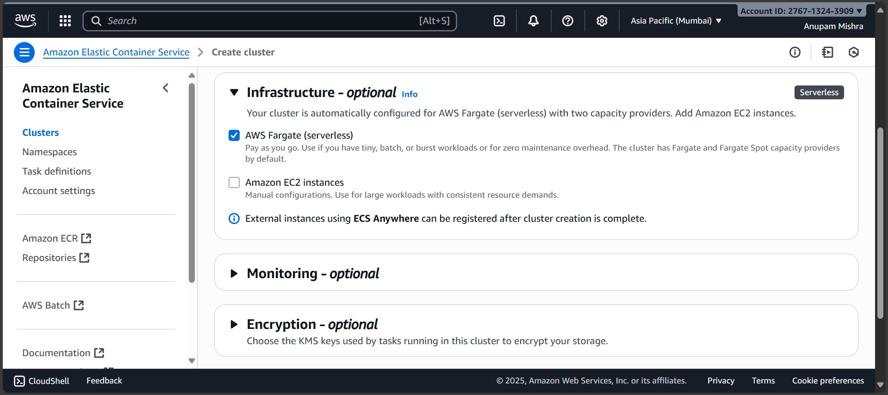

2. Register a Task Definition:

Task definition configuration

- Task definition family: sample-app

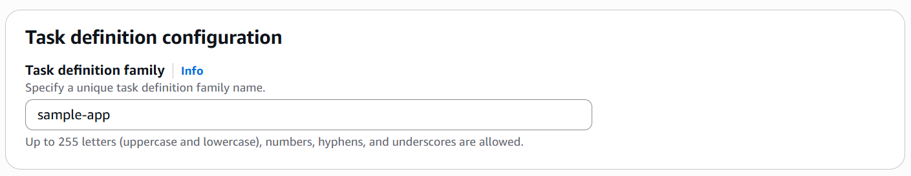

Infrastructure requirements

- Launch type: AWS Fargate
- OS, Architecture: Leave default Linux/X86_64
- Network mode: awsvpc
- Task size: 1 vCPU, 3 GB memory
- Task role: none
- Task Execution role: Create new role
- Task Placement: Task placement constraints are not supported for AWS Fargate launch type.
- Fault injection: Leave Enable fault injection unchecked

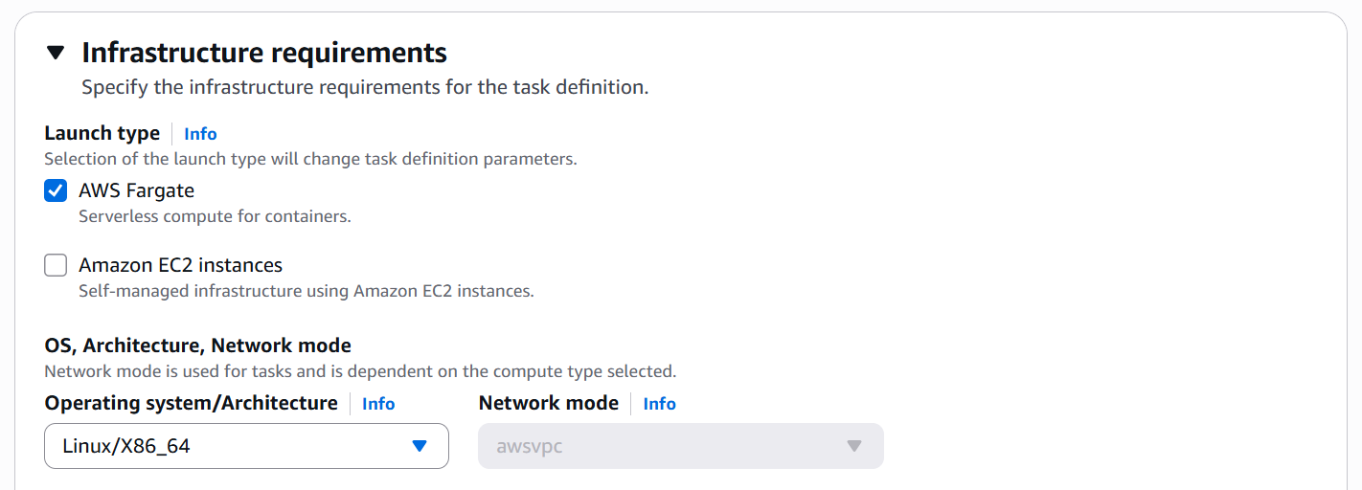
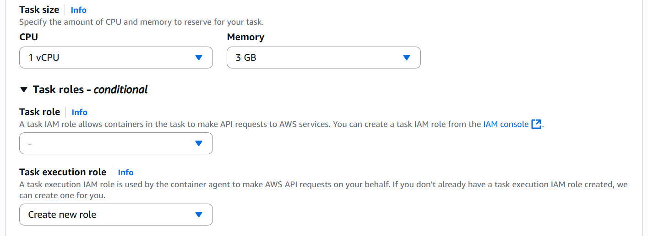
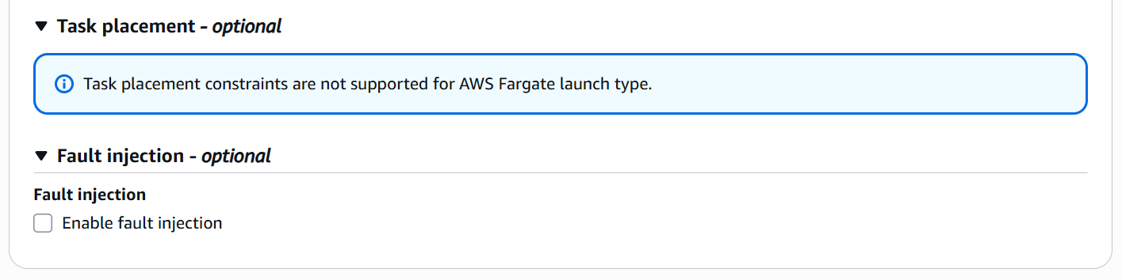

This will create the ecsTaskExecutionRole, which ECS uses to:

- Pull images securely from ECR.
- Write logs to CloudWatch.

Container

- Name: sample-app
- Image URL: 276713243909.dkr.ecr.ap-south-1.amazonaws.com/sample-app:latest
- Essential container: Yes
- Private registry: Leave Private registry authentication disabled
- Container Port: 3000
- Protocol: TCP
- App protocol: HTTP

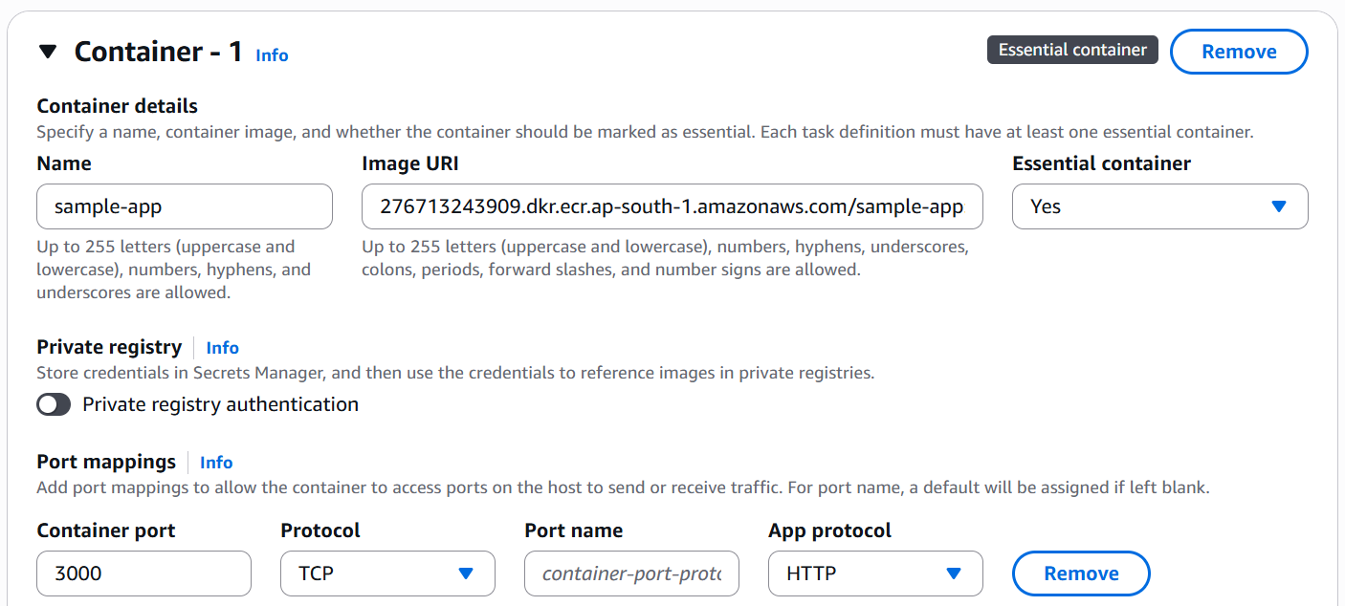

Leave other fields as defaults and click Create to finalize the container definition.

3. Create a Service:

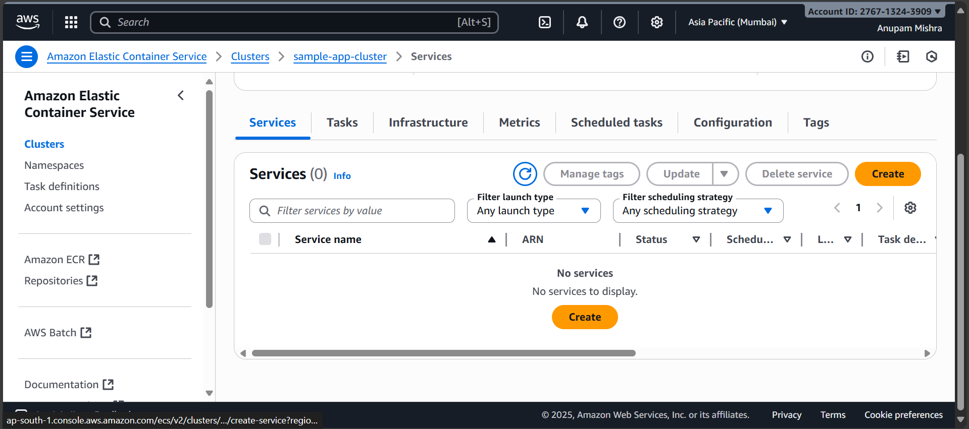

Service details

- Task definition family: sample-app
- Task definition revision: 1
- Service name: sample-app-service

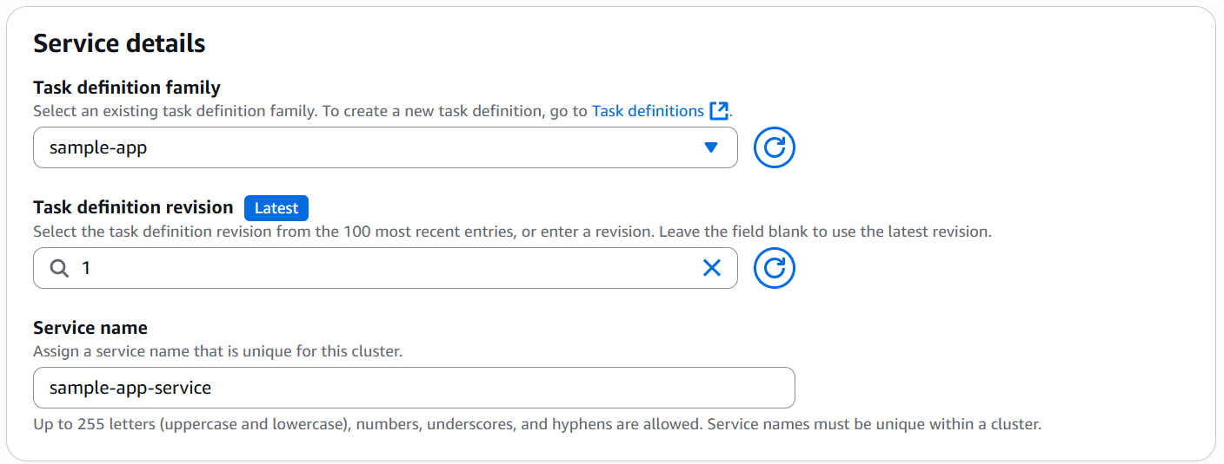

Environment

- Existing cluster: sample-app-cluster

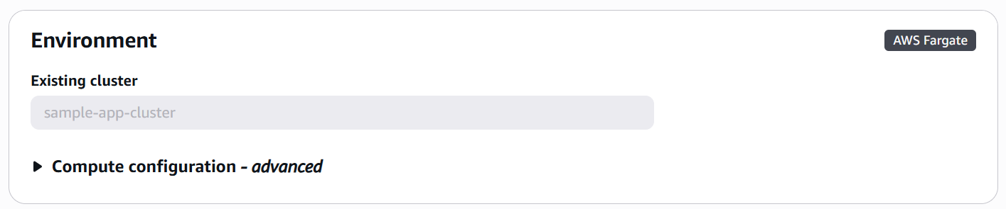

Deployment configuration

- Scheduling strategy: Replica
- Desired tasks: 1
- Availability Zone rebalancing: Leave Turn on Availability Zone rebalancing checked.
- Health check grace period: 0 seconds

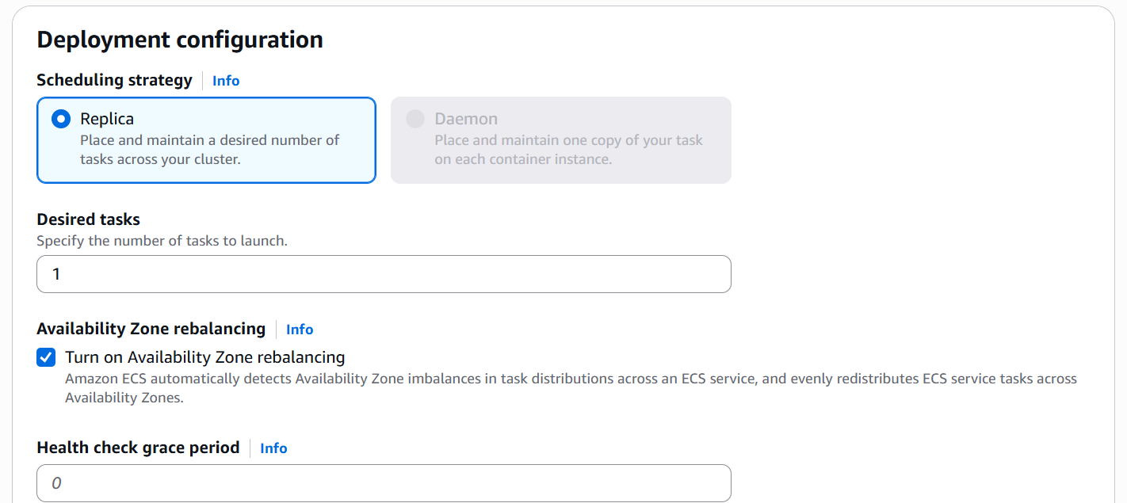

Networking

- VPC: Select your default VPC
- Subnets: Select all available subnets
- Security group: Select Use an existing security group.
- Security group name: Choose the default security group
- Public IP: Enabled

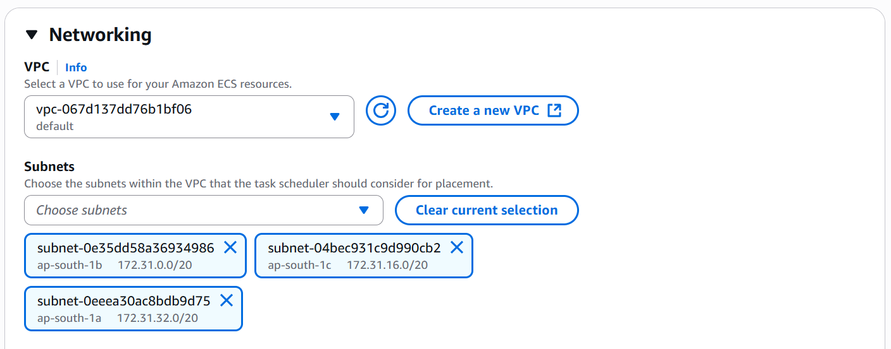
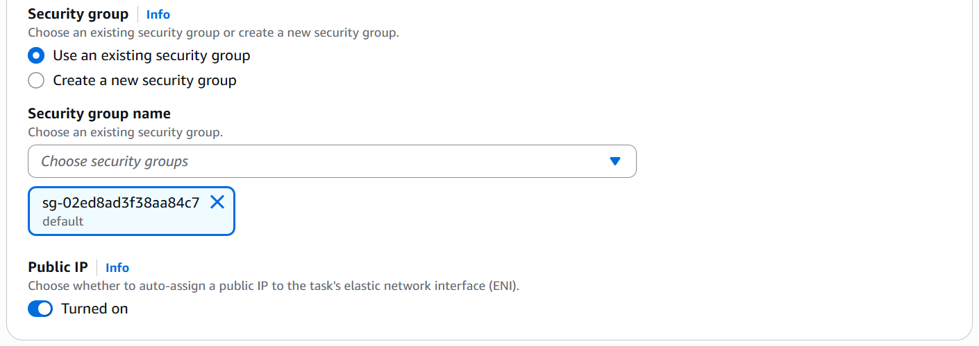

Step 7: Test the Application

1. In ECS Console, copy the Public IP of the running task.

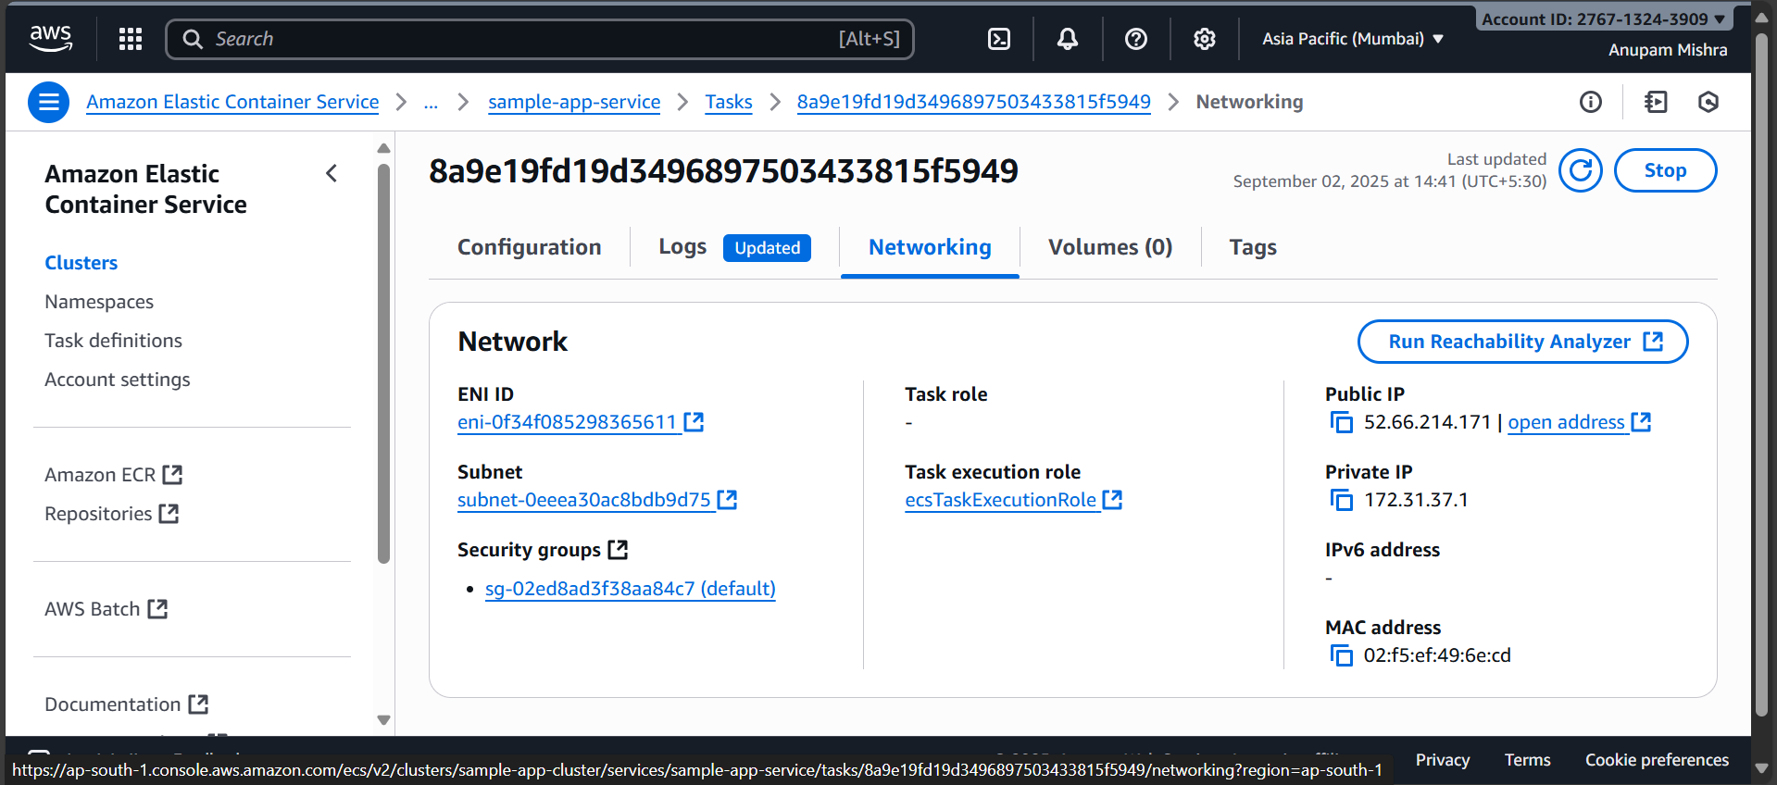

2. Test in terminal:

curl http://52.66.214.171:3000/health

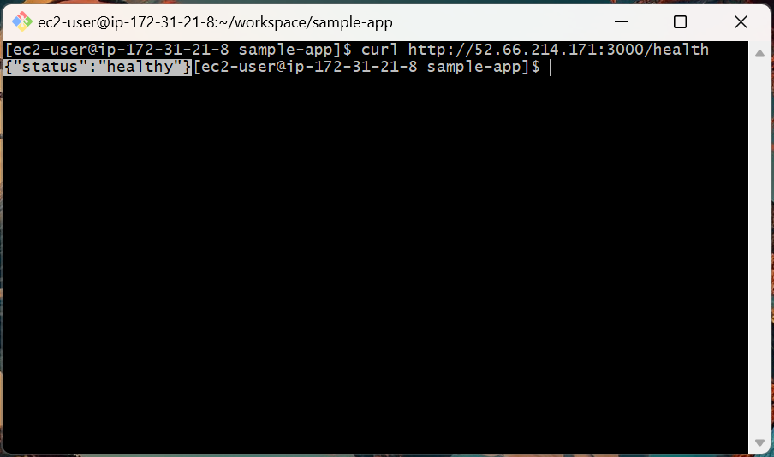

3. Open in your browser:

http://52.66.214.171:3000/

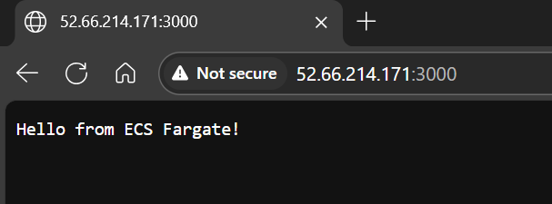

Topics Covered:

1. Built and tested a simple Node.js application.

2. Dockerized the app and confirmed it works locally.

3. Created an IAM user (ecs-deployer) with programmatic access for ECR/ECS.

4. Pushed Docker image to Amazon ECR in ap-south-1.

5. Deployed a container on ECS Fargate using AWS Console.

6. Verified successful deployment via public endpoint.

